Advanced Systematic Trading
Multi-Strategy, Multi-Asset Books With Dynamic, Regime-Aware Risk Management
Combining and Dynamically Re-Weighting Many Uncorrelated, Decaying Edges
A Level 5 module in the Quantitative Finance Curriculum
Covers: Multi-factor/cross-sectional/market-neutral strategies · volatility/relative-value/event-driven/macro/cross-asset strategies · crypto/FX/futures systematic trading · dynamic hedging/risk budgets · regime-dependent allocation · correlation breakdowns · tail-risk/liquidity-aware portfolio construction

Table of Contents
How to Use This Guide
What You Need to Know Before Starting
Understand Before Proceeding
Why It Matters
How This Connects to the Rest of the Curriculum
Glossary of Recurring Terms
Part 1 — From Single Edge to Multi-Strategy Book
1.1 Why Single-Strategy Edges Decay and Crowd
1.2 The Diversification Argument for a Multi-Strategy Book
Part 2 — The Strategy Universe Across Asset Classes
2.1 Multi-Factor, Cross-Sectional & Market-Neutral Equity
2.2 Volatility & Relative-Value Strategies
2.3 Event-Driven & Macro/Cross-Asset Strategies
2.4 Systematic Crypto, FX & Futures Trading
Part 3 — Correlation Breakdowns and Regime Dependence
3.1 Why Correlations Rise Precisely When You Need Them Not To
3.2 Detecting Regimes: Structural Breaks and Hidden Markov Models
3.3 Regime-Dependent Allocation in Practice
Part 4 — Dynamic Hedging, Risk Budgets & Tail Risk
4.1 Risk Budgeting as the Book's Operating System
4.2 Dynamic Hedging Mechanics
4.3 Tail-Risk and Liquidity-Aware Construction
Part 5 — Capacity, Crowding & the Limits of Scale
5.1 The Quant Quake: Crowding Made Visible
5.2 Capacity Constraints and Sharpe Decay
Practical Exercise
Common Beginner Mistakes
Advanced Extensions
Professional Applications
Where to Go Next

How to Use This Guide
This is the Level 5 module in the quantitative finance curriculum: running a diversified book of systematic strategies across asset classes with dynamic, regime-aware risk management. It assumes fluency with the Level 3 construction toolkit (sizing, risk parity, mean-variance, constraints) and applies that toolkit one level up — across strategies and asset classes rather than within a single one. Given the level, sections here are written tighter and denser than earlier modules: expect more claims per paragraph, grounded throughout in published research and documented market episodes rather than illustrative exercises alone.

What You Need to Know Before Starting
- Portfolio Construction (Level 3) — sizing, risk parity/ERC, mean-variance optimisation, and constraints; this module is that toolkit applied across strategies and asset classes rather than within one.
- Time Series (regime/structural-break concepts) — stationarity, structural breaks, and the basic idea that a time series' generating process can change; Part 3 builds directly on this.
- Risk Metrics — volatility, correlation, drawdown, and tail measures (VaR/CVaR); assumed fluent, not re-derived here.

Understand Before Proceeding
Prerequisite gate —
A backtested Sharpe ratio for a single strategy is not the object professional systematic trading optimizes. The object is the risk-adjusted return of the combined book, net of correlation that is unstable and rises exactly when diversification is needed most. Every part of this module assumes you have internalized that shift in unit of analysis — from strategy to book — before proceeding.

Why It Matters
Single-strategy edges decay and crowd. Professional systematic trading is about combining and dynamically re-weighting many uncorrelated, decaying edges — not finding one permanent edge and holding it forever. A multi-strategy hedge fund's real intellectual property is increasingly the allocation and risk layer sitting on top of its individual strategies, not any single signal underneath it.

How This Connects to the Rest of the Curriculum
- Research — Feeds directly from the Level 3 alpha-research pipeline, now combined across strategies and asset classes; a signal validated in isolation still has to earn its place in the book once correlation to existing risk is accounted for.
- Development — Requires multi-asset, multi-strategy research and execution infrastructure — Level 4 deliverables running at production scale, across many simultaneous live strategies rather than one.
- Trading — This is the trading track's core professional activity: running and dynamically managing a live systematic book, day to day, across regimes.

Glossary of Recurring Terms
Multi-strategy book — A portfolio combining many distinct, individually-validated trading strategies — often across asset classes — under a shared risk-budgeting and allocation layer.
Cross-sectional strategy — A strategy that ranks a universe of assets against each other at a point in time (e.g. by value, momentum, quality) and trades the relative ranking, rather than forecasting the absolute level of any one asset.
Market-neutral — A portfolio construction that removes net exposure to a broad market factor (typically via dollar- or beta-neutral constraints), so returns are driven by relative performance within the universe rather than the market's direction.
Relative-value strategy — A strategy that trades the price relationship between two related instruments (e.g. two bonds, a future and its underlying) expected to converge, rather than taking a directional view on either alone.
Event-driven strategy — A strategy that trades around discrete corporate or market events (mergers, earnings, index rebalances) whose outcome and timing are comparatively well-defined.
Regime — A persistent, latent state of the market (e.g. low-volatility trending vs. high-volatility mean-reverting) that shifts the statistical properties — mean, volatility, correlation — of asset returns.
Hidden Markov Model (HMM) — A statistical model that infers an unobserved (hidden) regime variable from observed data, assuming the regime evolves as a Markov chain — the standard tool for regime detection in systematic trading.
Correlation breakdown — The empirically well-documented tendency for asset and strategy correlations to rise sharply during market stress, eroding the diversification a portfolio appeared to have in calm conditions.
Risk budget — An explicit allocation of how much risk (rather than capital) each strategy or asset class is permitted to contribute to the book, dynamically adjusted as conditions change.
Dynamic hedging — Continuously adjusting a hedge position in response to changing market conditions or exposures, rather than setting a static hedge ratio once.
Tail risk — The risk of extreme, low-probability losses in the far left tail of the return distribution — the specific risk that symmetric measures like volatility can systematically underweight.
Crowding — The state where many market participants hold similar positions based on similar signals, such that a shared shock (or one participant's forced deleveraging) can cause correlated, mutually-reinforcing losses across all of them.
Capacity — The maximum amount of capital a strategy can deploy before trading costs and market impact erode its Sharpe ratio below an acceptable threshold.
Liquidity-aware construction — Portfolio construction that explicitly accounts for how quickly (and at what cost) positions could be unwound under stress, not only their expected risk and return in normal conditions.

Part 1 — From Single Edge to Multi-Strategy Book

1.1 Why Single-Strategy Edges Decay and Crowd
No systematic edge is permanent. As more capital and more managers discover and trade the same signal, its returns compress — a documented pattern across pairs trading, momentum, and most published academic anomalies once they entered widespread institutional use. Decay accelerates through three related channels: growing competition for the same edge, capacity constraints that bind as a strategy's own AUM grows (Part 5), and outright regime change, where a strategy that worked in one market environment stops working in another without necessarily ever "failing" in a statistical sense.
The practical consequence is that a single-strategy allocator is running a business with a shrinking half-life. Professional systematic trading manages around this by running many such edges simultaneously, so that any one strategy's decay is a manageable drag on the book rather than an existential threat to the fund.

1.2 The Diversification Argument for a Multi-Strategy Book
The core argument is a direct extension of Level 3 portfolio construction: if strategies' return streams are genuinely uncorrelated, combining them at the risk-budget level (not just the position level) produces a Sharpe ratio for the book that exceeds any individual constituent's, and a materially smoother equity curve, since idiosyncratic drawdowns in different strategies rarely coincide.
SR_book ≈ SR_avg × √( N / (1 + (N−1)ρ̄) )
where SR_avg is the average standalone Sharpe ratio of N combined strategies and ρ̄ is their average pairwise correlation. This relationship is precisely why average correlation, not any individual strategy's own Sharpe ratio, is the single most important input to multi-strategy book construction — and precisely why Part 3's correlation-breakdown problem threatens the entire premise.
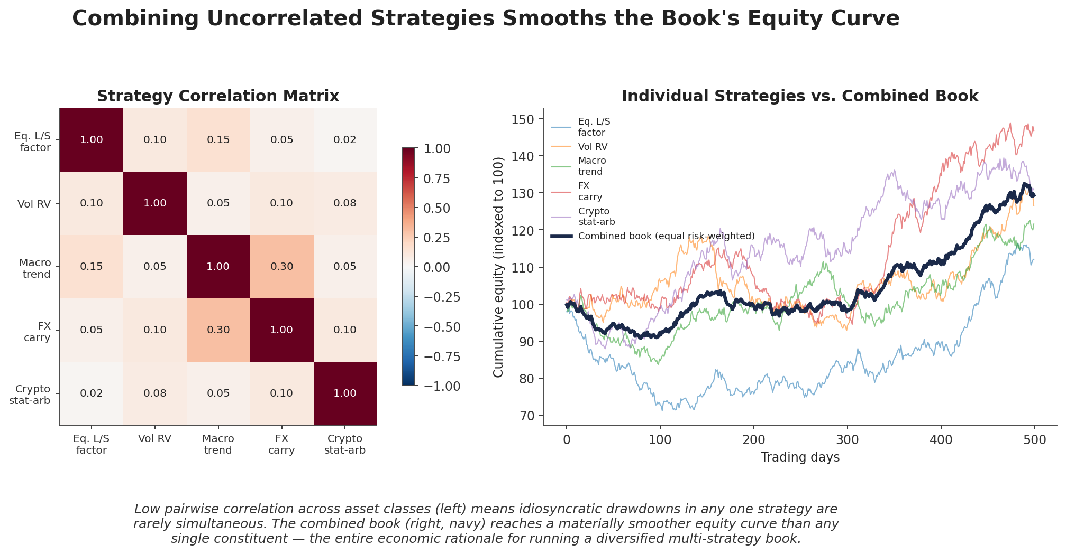
Figure 1.1 — Five low-correlation strategies across equities, volatility, macro, FX, and crypto (left) combine into a materially smoother book equity curve (right, navy) than any single constituent — the diversification argument made concrete.

Part 2 — The Strategy Universe Across Asset Classes
A professional systematic book typically spans several structurally distinct strategy families. Each family has a different edge, a different risk profile, and — critically — a different, low-correlation relationship to the others, which is the entire point of combining them.

2.1 Multi-Factor, Cross-Sectional & Market-Neutral Equity
Cross-sectional equity strategies rank a stock universe on one or more factors (value, momentum, quality, low-volatility) and go long the top-ranked names, short the bottom-ranked names, holding the portfolio dollar- and often beta-neutral (Level 3, Part 4). Multi-factor construction combines several such signals — typically negatively or weakly correlated with each other — into one blended ranking, which is itself a Level 3 sizing-and-combination problem applied specifically within equities.

2.2 Volatility & Relative-Value Strategies
Volatility strategies trade the well-documented gap between options' implied volatility and subsequently realised volatility — systematically selling variance earns a persistent risk premium in most conditions, but carries sharp, correlated tail risk exactly when markets are stressed (Part 4). Relative-value strategies instead trade the price relationship between related instruments expected to converge — two bonds along a curve, a future against its underlying, or two correlated equities — profiting from convergence largely independent of the broader market's direction.

2.3 Event-Driven & Macro/Cross-Asset Strategies
Event-driven strategies trade around discrete, comparatively well-defined events — merger arbitrage around announced M&A deals, earnings-drift strategies, index-rebalance flows — where the source of return is the event's resolution rather than a broad market view. Macro and cross-asset strategies instead take systematic positions across currencies, rates, commodities, and equity indices based on macroeconomic signals (growth, inflation, monetary policy surprises), and are structurally the most naturally diversifying strategy family relative to single-market equity strategies, since their return drivers are macro regime rather than any individual company's fundamentals.

2.4 Systematic Crypto, FX & Futures Trading
The same cross-sectional, relative-value, and trend-following techniques developed for equities and traditional futures extend naturally to crypto and FX markets, with important structural differences: crypto markets trade continuously (no close, no overnight gap risk in the traditional sense) and have historically exhibited both higher volatility and faster signal decay than developed-market equities as competition intensified; FX and futures markets offer deep, centrally-cleared liquidity that makes them a natural home for the largest, most capacity-constrained macro and trend strategies precisely because of that liquidity depth (Part 5).
Strategy family | Primary risk driver | Typical correlation to equity beta
Multi-factor equity market-neutral | Factor crowding / unwind risk | Low by design (beta-neutral)
Volatility / relative-value | Tail / convergence risk | Low in calm markets, rises sharply in stress
Event-driven | Deal-break / event risk | Low, idiosyncratic to each event
Macro / cross-asset | Regime / policy-surprise risk | Structurally low; can be negative in crises
Systematic crypto / FX / futures | Liquidity & regime risk | Varies; trend strategies often crisis-positive

Part 3 — Correlation Breakdowns and Regime Dependence

3.1 Why Correlations Rise Precisely When You Need Them Not To
It is well documented across individual stocks, country equity markets, currencies, and hedge fund return streams that correlations rise in down markets, especially in sharp crashes — an effect visible well before the 2008 financial crisis in the academic literature, yet one that still seemed to surprise many investors when it happened at scale. Published estimates put average pairwise equity correlation at roughly 40% in normal conditions versus roughly 70% during the 2008 crisis, with commodity-equity correlation jumping from near zero to roughly 0.6 over the same period; a similarly abrupt correlation spike, of comparable magnitude, occurred again during the March 2020 COVID panic. The mechanism is largely liquidity-driven rather than purely informational: under margin calls and redemption pressure, funds are forced to sell whatever is liquid, not necessarily what they would prefer to sell, dragging unrelated markets down together.
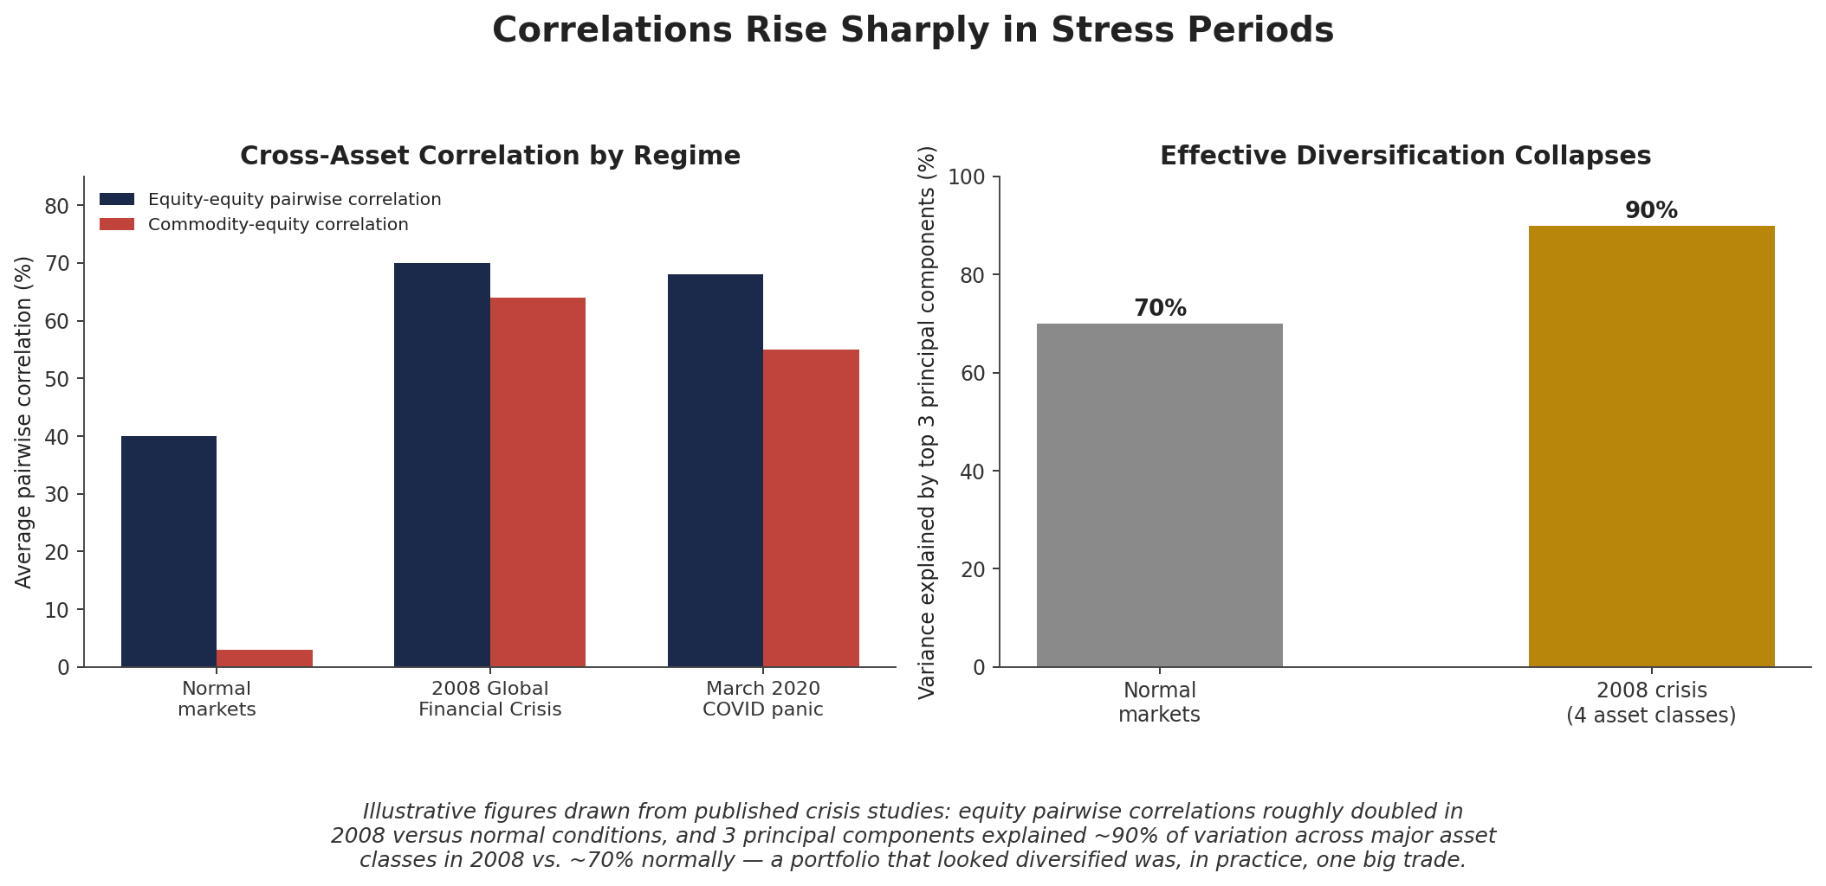
Figure 3.1 — Cross-asset correlations documented in 2008 and 2020 crisis studies roughly doubled versus normal conditions; a handful of principal components explained far more of the cross-asset variance during the crisis than in calm markets — a diversified-looking book was, in practice, one concentrated trade.
Common beginner mistake —
Assuming strategy correlations are stable — they typically rise sharply in stress periods, exactly when diversification is needed most. A risk model calibrated purely on calm-period history will systematically understate tail risk; some practitioners estimate static models can misjudge tail risk by 40–60% relative to crisis-period correlations.

3.2 Detecting Regimes: Structural Breaks and Hidden Markov Models
Since regimes are not directly observable, they must be inferred from data. Hidden Markov Models are the standard tool: a small number of latent states (e.g. "low-volatility bull" and "high-volatility bear") are assumed to generate observed returns with different means and volatilities, and the model — fit via the Baum-Welch expectation-maximization algorithm — infers both the transition probabilities between states and, at each point in time, the probability the market currently occupies each one. Academic work extending this to more than two states (distinguishing, for example, a low-volatility bull, a high-volatility bull, and a genuine crash state) finds the added granularity materially improves allocation decisions relative to a simple two-state model.
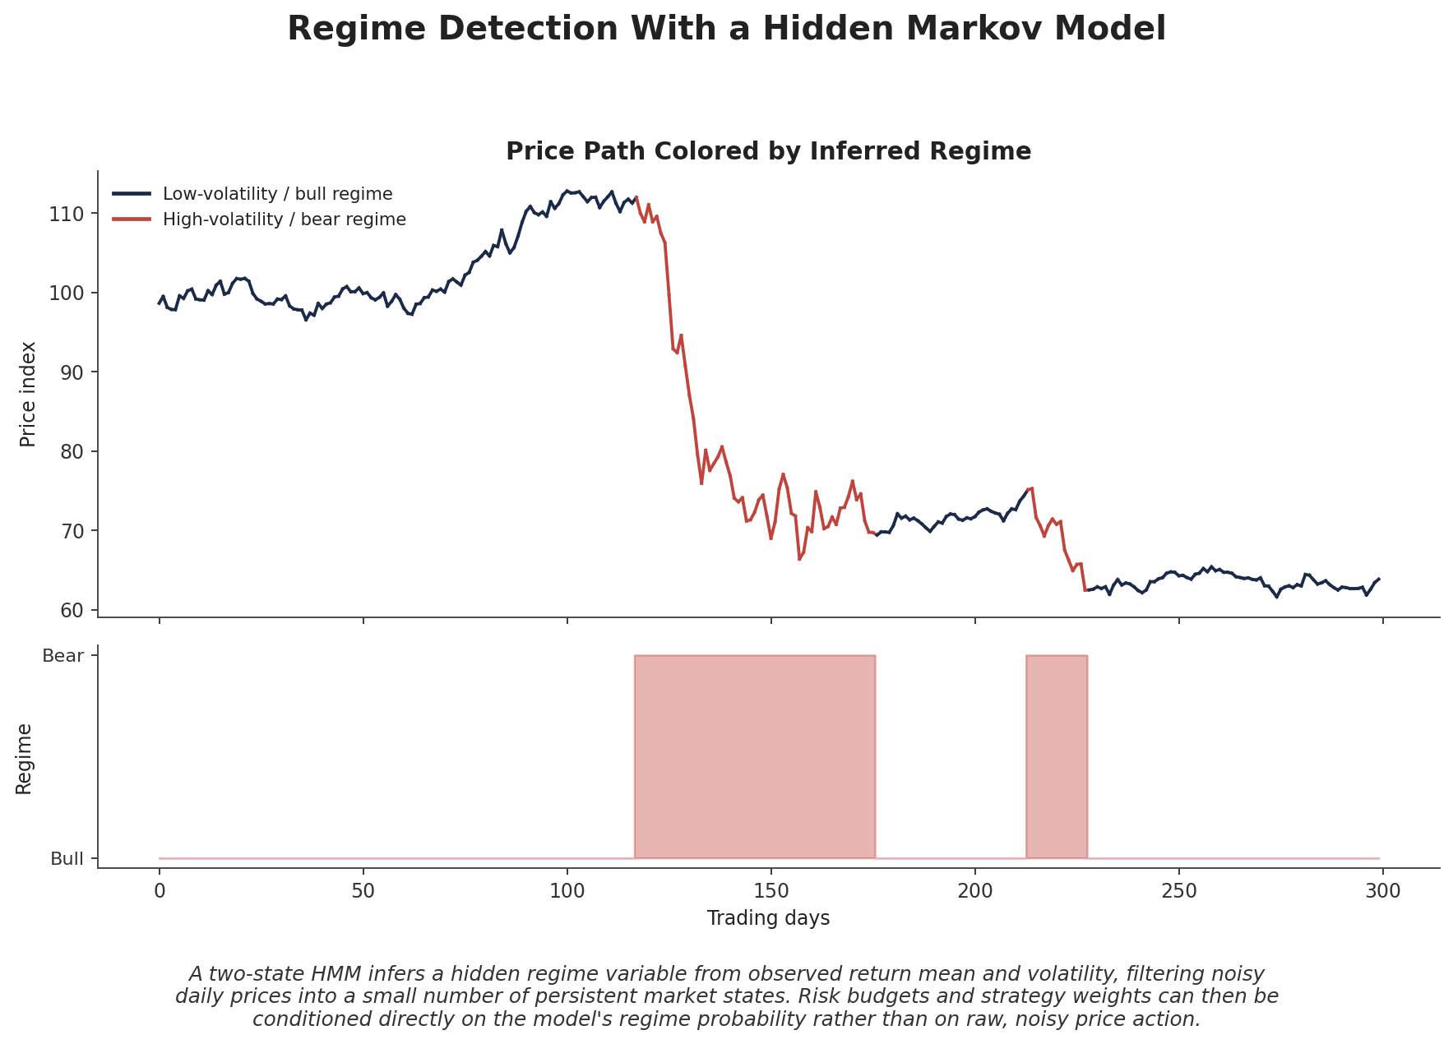
Figure 3.2 — A two-state HMM filters a noisy daily price series into a small number of persistent regimes, each with a distinct return mean and volatility, that risk budgets can condition on directly.
from hmmlearn.hmm import GaussianHMM
import numpy as np

returns = returns.reshape(-1, 1) # daily strategy or book returns
model = GaussianHMM(n_components=2, covariance_type='full', n_iter=200)
model.fit(returns)

regime = model.predict(returns) # inferred regime at each date
regime_probs = model.predict_proba(returns) # soft probability of each regime

3.3 Regime-Dependent Allocation in Practice
Once a regime signal exists, it feeds directly into the risk-budgeting layer covered in Part 4: gross exposure, leverage, and cross-strategy risk budgets are scaled down as the model's inferred probability of a high-correlation, high-volatility regime rises, and scaled back up as that probability falls. This is a structurally different mechanism from simply reducing exposure after a loss has already occurred — a well-specified regime model can shift allocation ahead of, or concurrently with, the correlation spike itself, rather than purely reactively.

Part 4 — Dynamic Hedging, Risk Budgets & Tail Risk

4.1 Risk Budgeting as the Book's Operating System
A risk budget assigns each strategy or asset class a target share of total book risk (not capital), and — unlike the static risk parity of Level 3 — updates that target continuously as conditions change: shrinking a strategy's budget as its realised volatility rises, and shrinking budgets across the board as cross-strategy correlation rises, since realised diversification (not nominal diversification) is what the budget is meant to protect.
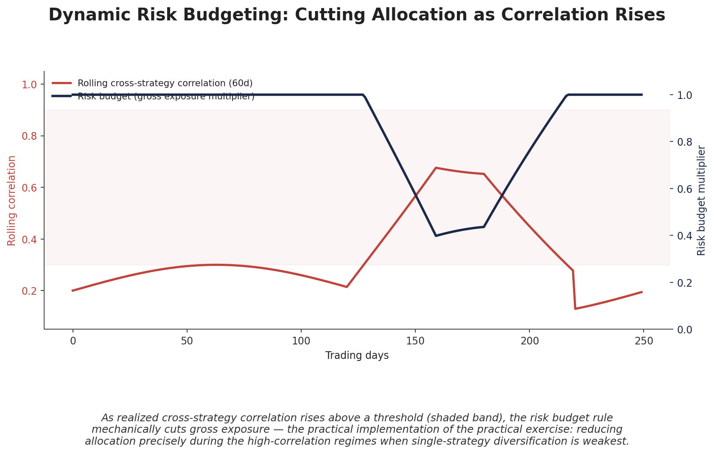
Figure 4.1 — As rolling cross-strategy correlation rises above a threshold, the risk-budget rule mechanically cuts gross exposure — reducing allocation precisely during the regimes when diversification is weakest, the mechanism this module's practical exercise builds directly.

4.2 Dynamic Hedging Mechanics
Dynamic hedging extends this idea to specific, unwanted exposures the book accumulates incidentally — a net beta tilt that drifts as individual strategies' positions evolve, or a currency exposure that builds up across otherwise-unrelated strategies trading in the same region. Rather than re-optimizing the entire book, a dynamic overlay continuously trades a small hedging instrument (an index future, a currency forward) to keep the unwanted exposure near a target band, freeing individual strategies to trade their own signal without each one independently managing book-level exposures it cannot see.

4.3 Tail-Risk and Liquidity-Aware Construction
Because correlation breakdown concentrates losses exactly in crisis states, many multi-strategy books run an explicit tail-risk overlay alongside risk budgeting — commonly systematic out-of-the-money index puts, a long-volatility program, or a trend-following sleeve, which tends to be positively carried over long samples and performs best when losses unfold gradually rather than in a single gap. Convex options-based protection reprices immediately in a sudden crash but is typically the more expensive form of insurance: naive systematic put-buying programs have historically cost on the order of 1.5–2.5% of notional per year in premium drag during calm periods, according to several published cost studies, which is precisely why sizing the overlay itself is a risk-budgeting decision rather than a fixed allocation.
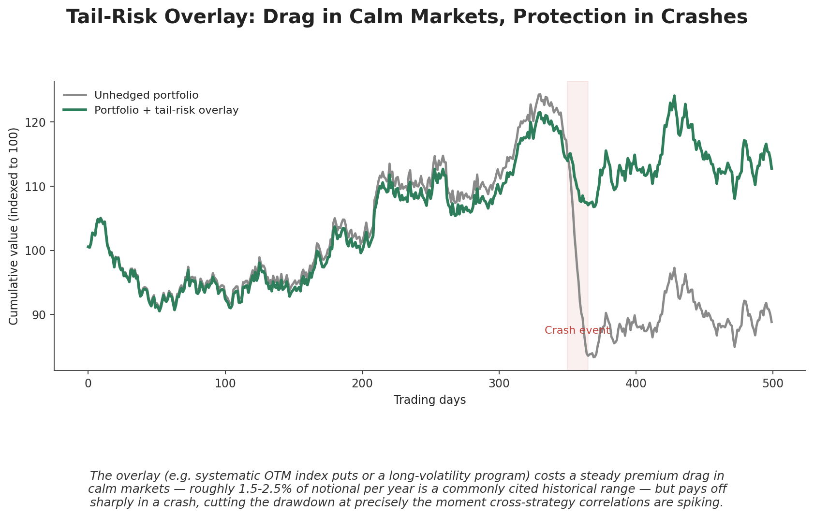
Figure 4.2 — A tail-risk overlay costs a steady premium drag in calm markets but cuts the drawdown sharply during a crash — protection concentrated exactly where correlation breakdown otherwise concentrates losses.
Liquidity-aware construction is the final, often-overlooked layer: position sizes are constrained not only by target risk, but by how quickly each position could realistically be unwound under stress, since the same liquidity that dries up during a correlation-breakdown event (Section 3.1) is exactly what a book needs to de-risk quickly when its risk budget signals a cut.

Part 5 — Capacity, Crowding & the Limits of Scale

5.1 The Quant Quake: Crowding Made Visible
In August 2007, several of the era's most successful quantitative equity market-neutral funds suffered severe, highly correlated losses over a few trading days, followed by a substantial recovery within weeks — an episode now known as the "Quant Quake." The academic forensic analysis (Khandani and Lo, 2011) concluded the proximate cause was the forced deleveraging of one or more large, similarly-constructed portfolios, which cascaded into correlated losses across many funds that, it turned out, were trading substantially the same factors — value, momentum, and short-term reversal — despite each manager believing their process was distinctive. The episode remains the canonical case study in crowding risk: strategies with no shared economic driver can still suffer simultaneous losses purely because too much capital is chasing the same signal with similar risk models.
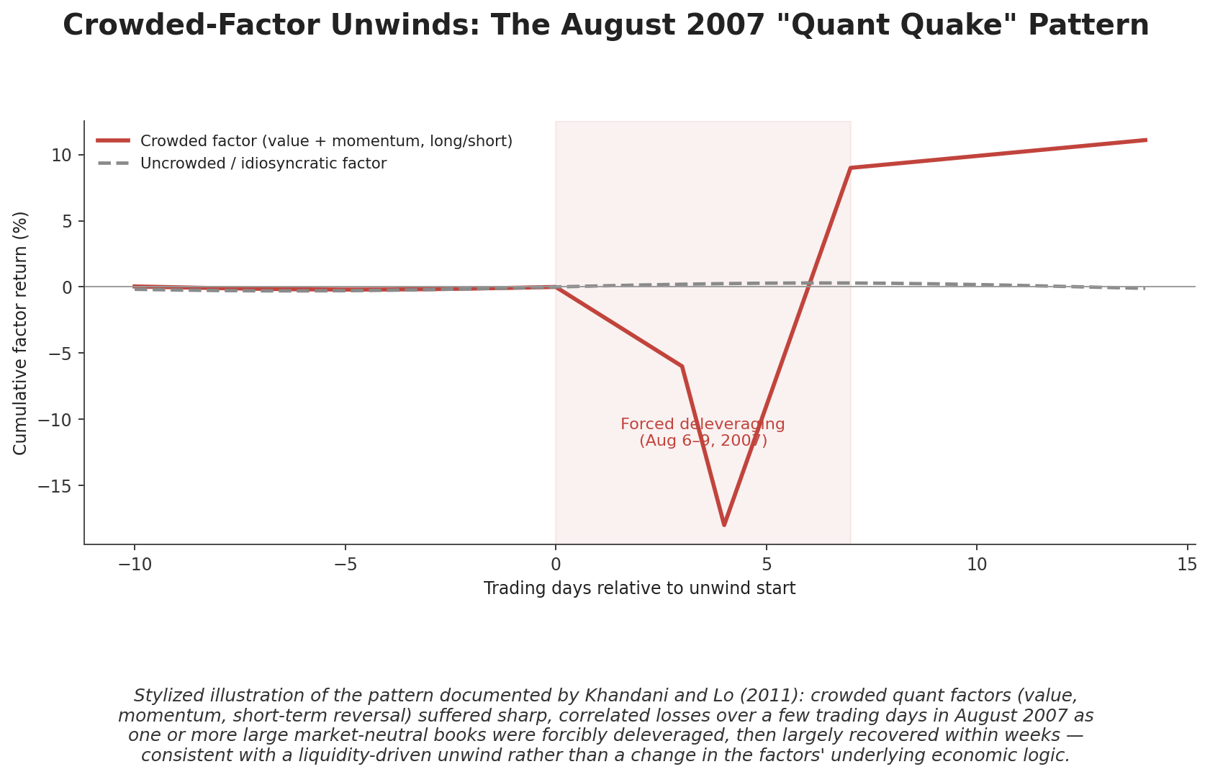
Figure 5.1 — Stylized illustration of the August 2007 pattern: crowded factors suffered a sharp, correlated drawdown over a few trading days during forced deleveraging, then largely recovered within weeks — consistent with a liquidity-driven unwind rather than a change in the factors' underlying logic.
With systematic equity strategies' assets under management estimated at well over a trillion dollars industry-wide today, and factor exposures now available even to retail investors through ETFs, the crowding dynamics documented in 2007 have if anything intensified. A practical, partial defense is monitoring a strategy's return correlation to popular factor benchmarks and to short-interest concentration in its holdings — a high R² against a generic factor ETF is a direct signal of crowding exposure, independent of the strategy's own reported Sharpe ratio.

5.2 Capacity Constraints and Sharpe Decay
Under-appreciating capacity constraints when scaling a strategy that worked well at small size is a related, equally common failure mode. As AUM grows, larger orders must be worked more slowly to avoid excessive market impact (Level 3 execution material), which defers trades, lets marginal alpha decay before it is captured, and mechanically drags realised Sharpe ratio below its small-size, frictionless level. The decay is steeper for strategies trading less-liquid instruments or built on faster-decaying signals; a commonly cited rule of thumb places a strategy's practical capacity ceiling near the scale at which Sharpe ratio has fallen roughly 30% from its frictionless value.
SR(scale) ≈ SR* / ( 1 + market-impact & deferral costs as a function of scale )
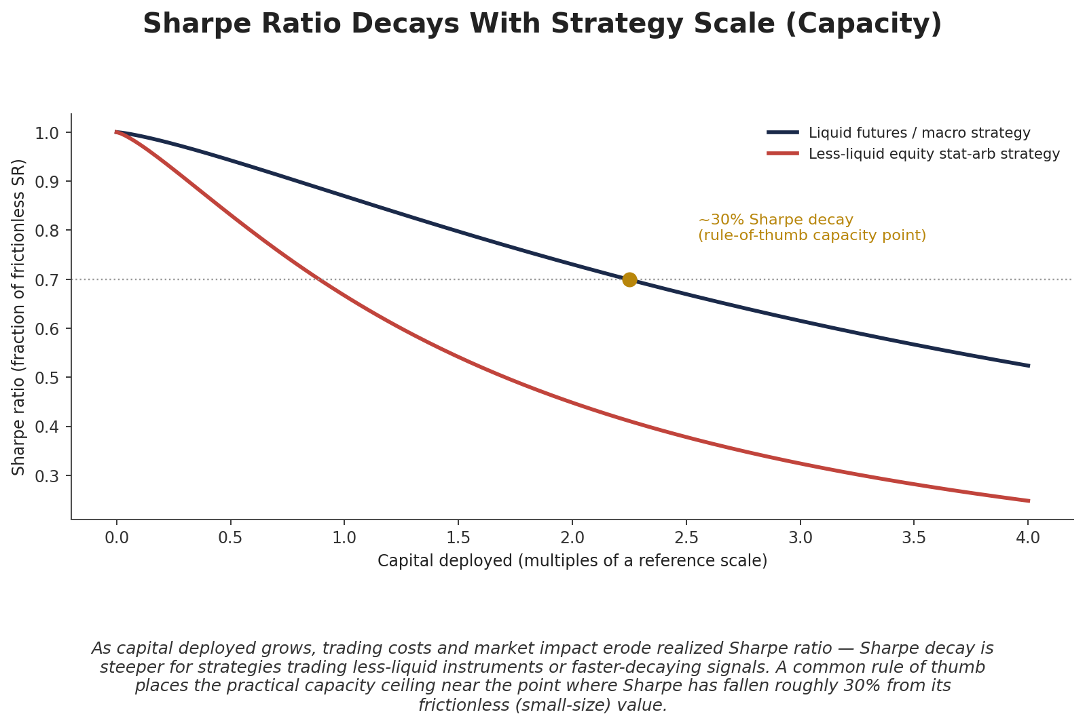
Figure 5.2 — Sharpe ratio decays as capital deployed grows, more steeply for less-liquid strategies. The ~30% decay point is a commonly used rule-of-thumb capacity ceiling.
Tip —
Reputable managers typically state a specific capacity number and a mechanism for reaching it — trading a known fraction of average daily volume per instrument — and close strategies to new capital before that ceiling binds. A manager who claims capacity "is not currently a constraint" is, in practice, usually describing a strategy that has not yet been scaled to find out where its ceiling actually is.

Practical Exercise
Combine three previously-validated strategies from different asset classes into one book with dynamic risk budgeting that reduces allocation during high cross-asset correlation regimes.
- Step 1 — Take three previously-validated strategies from different asset classes (e.g. an equity cross-sectional factor strategy, an FX carry strategy, and a futures trend strategy) with their own historical return series.
- Step 2 — Compute a rolling (e.g. 60-day) pairwise correlation across the three strategies' returns, and build a simple risk-budget rule that scales total book gross exposure down as that rolling correlation rises above a threshold (Section 4.1).
- Step 3 — Backtest the book two ways: static equal-risk weighting throughout, versus the dynamic risk-budget rule from Step 2, over a sample period that includes at least one known correlation-spike episode.
- Step 4 — Compare maximum drawdown and realised Sharpe ratio between the two versions — the dynamic version should show a materially smaller drawdown during the correlation-spike episode, at some cost to average exposure (and modestly lower average return) in calm periods.

Common Beginner Mistakes
- Assuming strategy correlations are stable — they typically rise sharply in stress periods, exactly when diversification is needed most (Section 3.1).
- Under-appreciating capacity constraints when scaling a strategy that worked well at small size — Sharpe ratio decays with deployed capital, sometimes sharply, and the decay is steepest for the least-liquid strategies (Section 5.2).

Advanced Extensions
- Regime-switching allocation models (HMM-based) — extending the two-state model in Section 3.2 to richer, multi-state or continuous-time regime models, and feeding regime probabilities directly into the optimisation objective rather than as a discrete overlay.
- Tail-risk overlays — the full construction, sizing, and cost-optimisation of a systematic convex hedging program (Section 4.3), including combining options-based and trend-following protection to balance crash-speed responsiveness against long-run carry cost.

Professional Applications
- Multi-strategy hedge fund books — the dominant institutional structure this entire module describes: many internal strategy teams or "pods," each running a distinct edge, combined and dynamically risk-budgeted by a central risk function.
- Systematic macro / cross-asset funds — funds whose core business is precisely the correlation-aware, regime-dependent allocation across asset classes covered in Parts 3–4, rather than any single alpha signal.

Where to Go Next
This module combined Level 3's single-strategy construction toolkit with regime-awareness and cross-asset correlation dynamics to produce a professional, book-level framework. From here, the Trading track's Level 5 modules cover running such a book live — execution at scale, real-time risk monitoring, and the operational discipline of a professional trading desk — while further Research-track modules extend the regime-detection and tail-risk material introduced here into the full advanced-extension topics: multi-state regime-switching models and systematic tail-hedging program design.

